**Most successful ICOs of 2017**

ICOs have rapidly become the new standard method of raising funds for cryptocurrency projects and start-ups. The practice of offering investors and enthusiast’s tokens in exchange for Bitcoin or Ethereum has proven to be extremely popular with a large number of projects raising millions of dollars in just a matter of days and sometimes even days. Just to give an understanding of the growing landscape of ICOs here is a list of the top 20 ICOs so far.

In just the space of 18 months the 20 biggest ICO’s have generated over 1.8 billion dollars in funding and this is just the beginning. 2017 has seen the inception of major cryptocurrency ICO projects, below is a brief overview of some of the most successful ICO projects of the year.

**Filecoin - $257 Million**

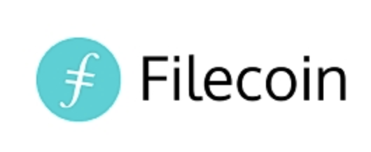Filecoin ICO blew its competition out of the water by raising a record 257 million. This was split into a $52 million presale and a second round of 205.8 million with Sequoia Capital, Y Combinator some of the firms that backed it. Filecoin is a Blockchain data storage network using a peer-to-peer system to store and secure data. Users would earn money by exchanging their free hard drive storage space for Filecoin tokens. An incredible $135 million were raised in just the first hour of launch of the ICO.

**Tezos - $232 Million**

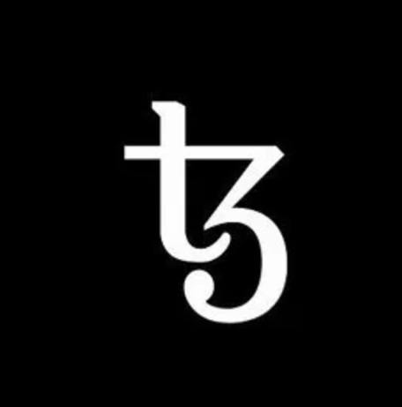 Tezos is a future-proof smart contract system like Ethereum but a key difference being that it incorporates a process for upgrading the protocol over time through a built-in consensus mechanism. Meaning that its token holders vote on protocol upgrades and these upgrades are conducted by a smooth evolution of the blockchain rather than having to hard fork, which is a split of the blockchain into two separate versions. In a 14-day period in July the ICO raised 232 million which was a record as of it’s closing date. However, they are currently embroiled in three separate class action suits after a publicised dispute between its creators and a revelation that Tezos tokens were sold as securities but were never registered as that.

**EOS – $180 Million**

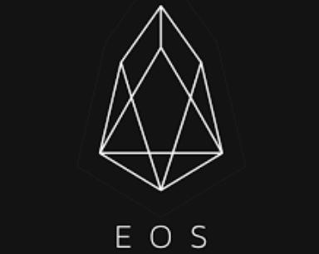 EOS was created by Block.one a start up that plans on building a blockchain operating system that would introduce a highly scalable and malleable architecture allowing developers to build flexible applications. What separates it from others is that EOS promises a blockchain architecture that has the potential to process millions of transactions per second, eliminate user fees and allow for easy integration and creation of decentralised apps across multiple avenues. With its creators claiming to build a platform that was an improvement over current industry leader, Ethereum. 1 billion EOS tokens were created and released in multiple stages over a span of 15 days to allow both individual and larger investors to purchase tokens.

**Bancor – $153 Million**

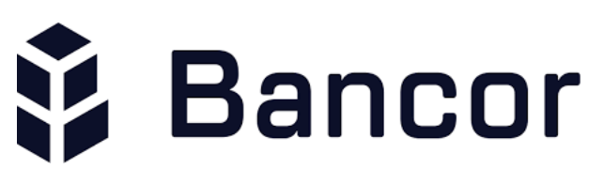Named after John Maynard Keynes concept of a global currency. Bancor seeks to build a decentralised exchange ecosystem allowing holders of multiple digital currencies to trade with each other without any risk to the security of their coins. The network would enable holders to create liquid smart tokens consisting of multiple digital assets with their own calculated price to be converted to other tokens without the need of a secondary party for exchange. In essence an individual could purchase a Bancor token that consisted of 30% Litecoin, 40% Ethereum and 30% Ripple thus making it easier to trade crypto currencies. The ICO proved to be very popular attracting many high profile names including venture capitalist Tim Draper.

**Status - $108 Million**

 Status is a mobile Ethereum OS with the goal of serving as a messenger, browser and wallet app. It shall also serve as a gateway to access decentralised applications built on Ethereum. Users could store, send and receive Ethereum directly on their phone whilst also sending encrypted messages without the need for a central server. Offering a simple tool to communicate with contacts and vendors, manage funds, Status is built in the same vein as WeChat, the messaging app dominating the Chinese market. Status raised the money by selling approximately 300,000 Ethereum which at that time came to about 108 million dollars.

**MobileGo - $53 Million**

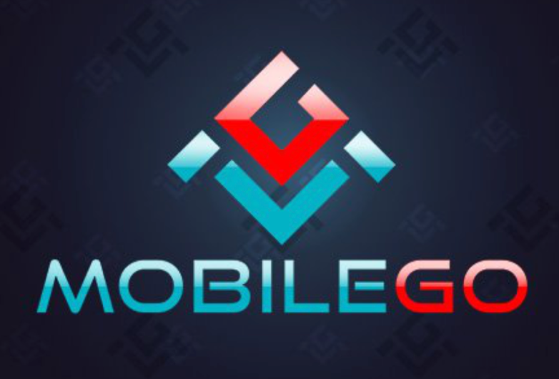 The first crypto-centric mobile gaming platform created to capitalise on the $50 Billion global mobile gaming market. MobileGo plans on capitalising on this market by being the first venture of its kind to provide a platform for gamers to download games and compete with each other in head-to-head matches and tournaments. Instead of third party organisers hosting events, players would control the tournament and be able to take part in peer to peer match-ups and tournaments internationally. They raised 53 million dollars in a month’s time of which about 50% of the money raised would go towards just marketing.

One for the future

**Capital Coin (2018)**

Arifa Khan a pioneer in the blockchain industry with years of experience in the banking sector having worked with some of the biggest investment banks in the world is taking on investment banks with her new venture Capital Coin. Capital Coin offers one of the potentially biggest real world applications for Blockchain technology. By building an electronic platform through which start-ups and businesses alike can raise capital through cryptocurrencies such as Bitcoin and Ethereum. Through a blockchain based platform, Capital Coin plans to replace the outdated Investment Banking model with a bunch of smart contracts and hand the power of fund raising back to the clients. Thus giving investors and seekers of capital a platform to interact freely with minimal friction and most importantly without the need for intermediaries. Its real life uses and potential makes it an ICO to look out for in the incoming year.